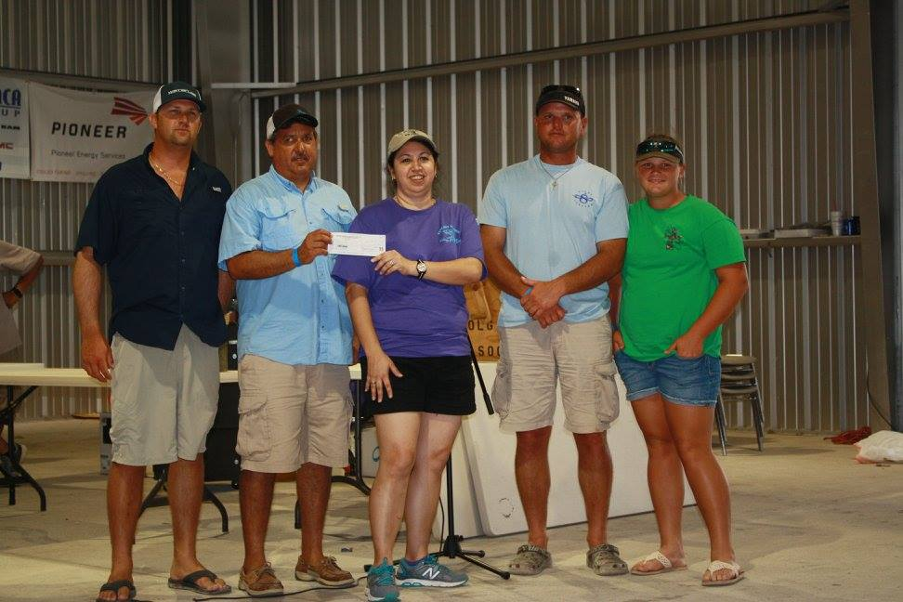
Biggest Redfish -Team Shoalwater, Sonny Leal, Benjamin Ondreas, Derek Roeben and Maise Ondreas

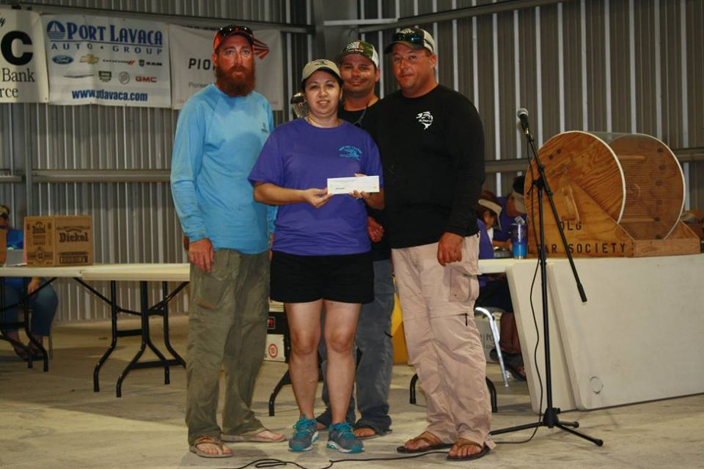
Biggest Speckled Trout-Team Starin'@Tails, Nathan Franz, Coleby Becker, Aaron Thomas and Sidgy Benoit

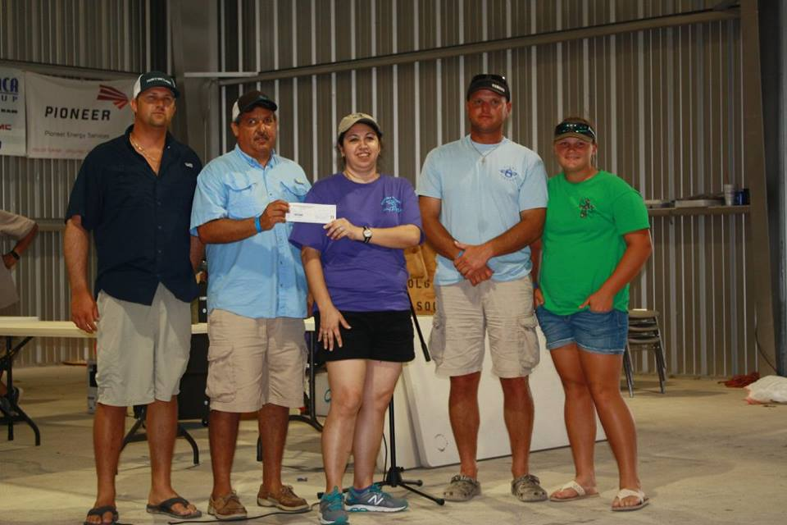
Biggest Redfish Stringer-Team Shoalwater, Sonny Leal, Benjamin Ondreas, Derek Roeben, and Maise Ondreas
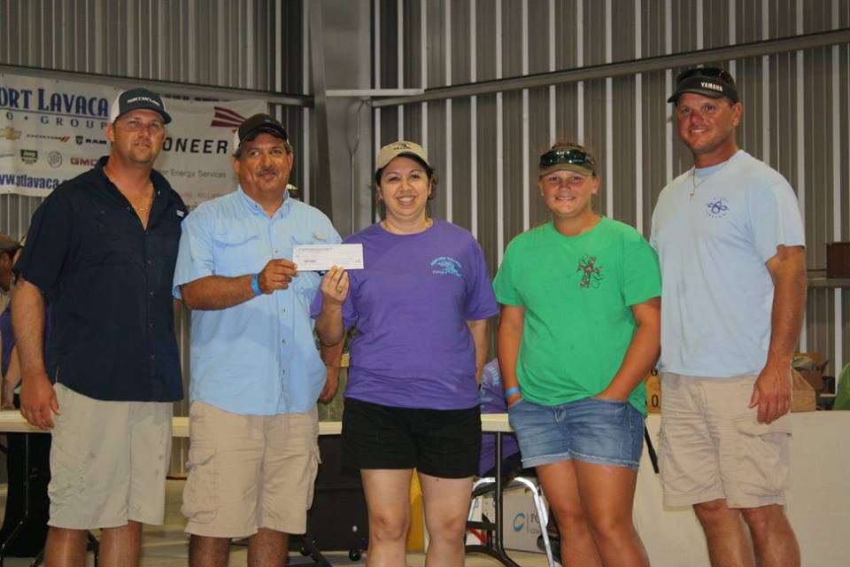
Biggest Speckled Trout Stringer-Team Shoalwater, Sonny Leal, Benjamin Ondreas, Derek Roeben, and Maise Ondreas

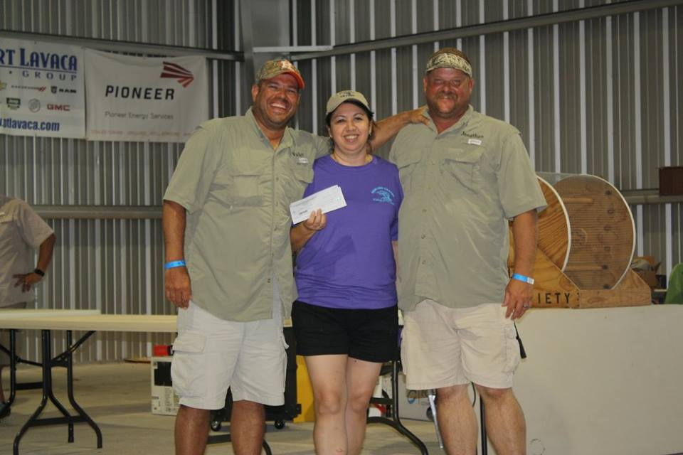
2nd Biggest Redfish Stringer Team Rusty Hooks, Walter Williams and Jonathon Medlin

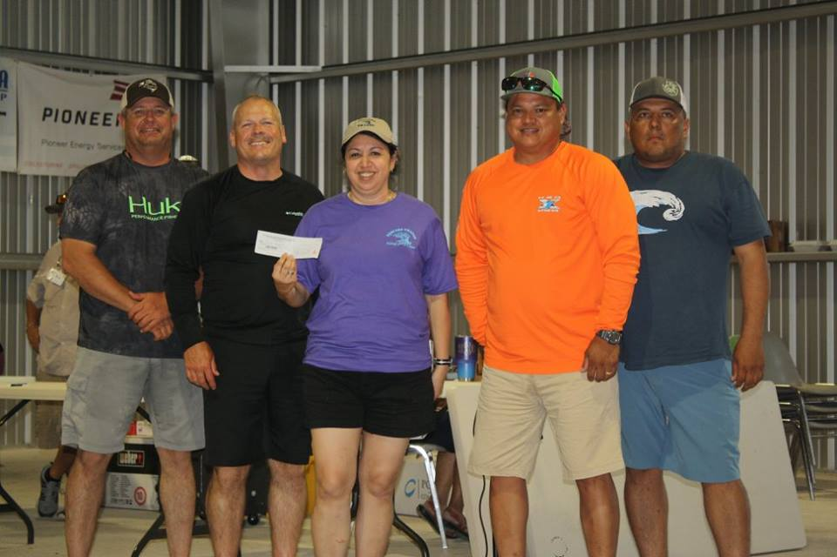
2nd Biggest Speckled Trout Stringer Team Them Fools-Rene Guzman, Mark Trevino, Shannon Ledwick and Greg Cox
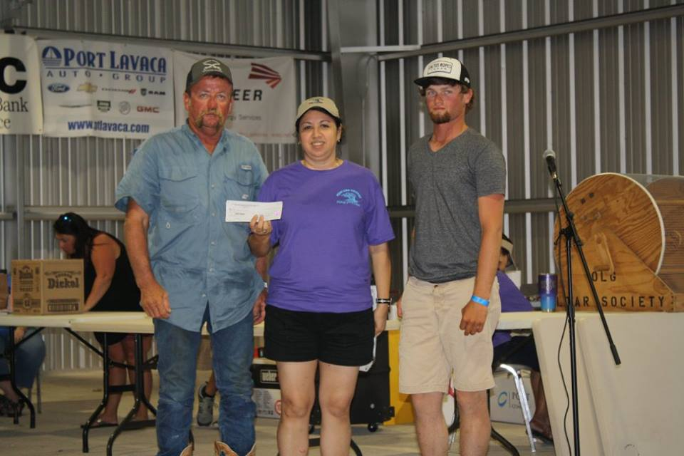
Biggest King Fish-Team Veronica Lea, Richard Richter, Adam Johnson, Colton Richter and Kylie Johnson

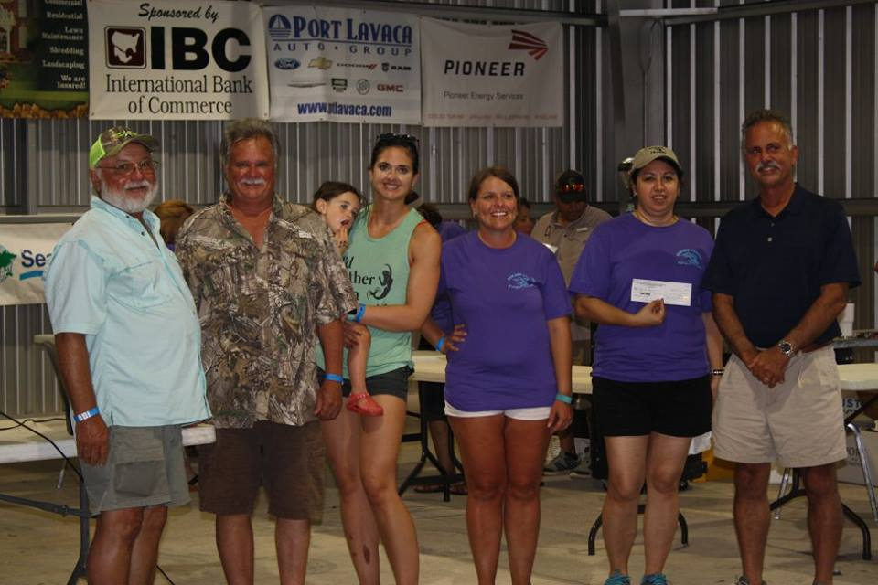
Biggest Red Snapper-Team Double Down, George Ganem, Mark Barefoot, Amy Kocian, Christina Shephard, Stacy Hendrix, and Larry Kocian

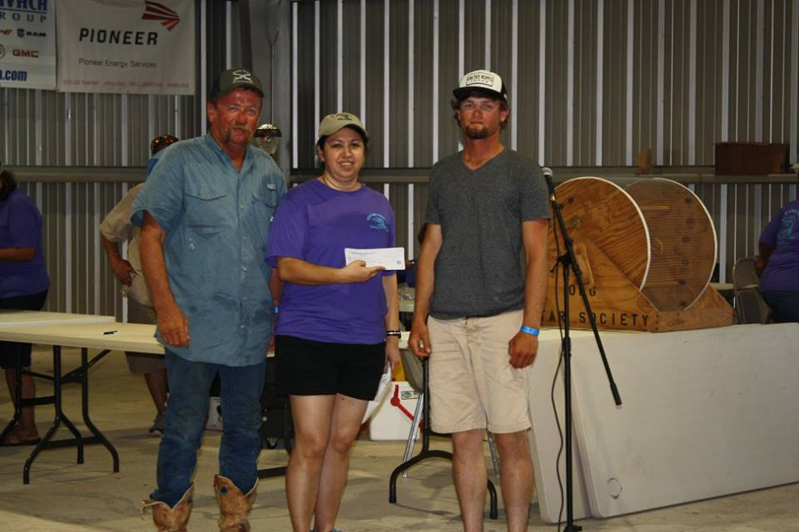
Biggest Fish-Team Veronica Lea, Richard Richter, Adam Johnson, Colton Richter, and Kylie Johnson

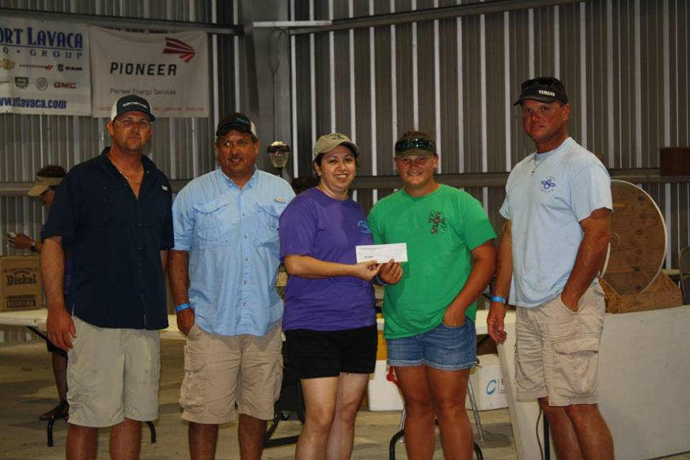
Spot Pot Winner-12 Spots Team Shoalwater, Sonny Leal, Benjamin Ondreas, Derek Roeben and Maise Ondreas

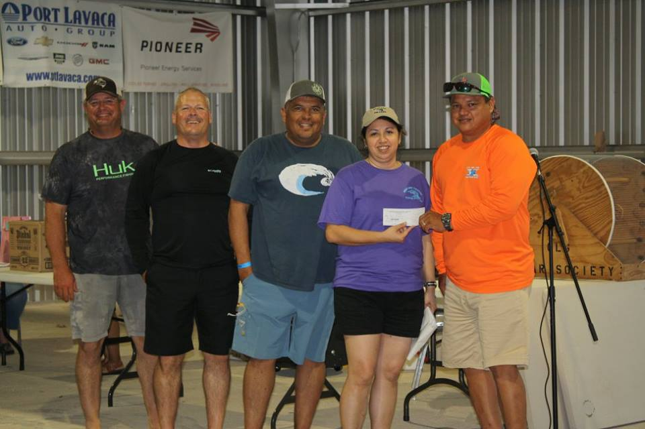
Triple Threat Winner-Team Them Fools, Rene Guzman, Mark Trevino, Shannon Ledwik and Greg Cox

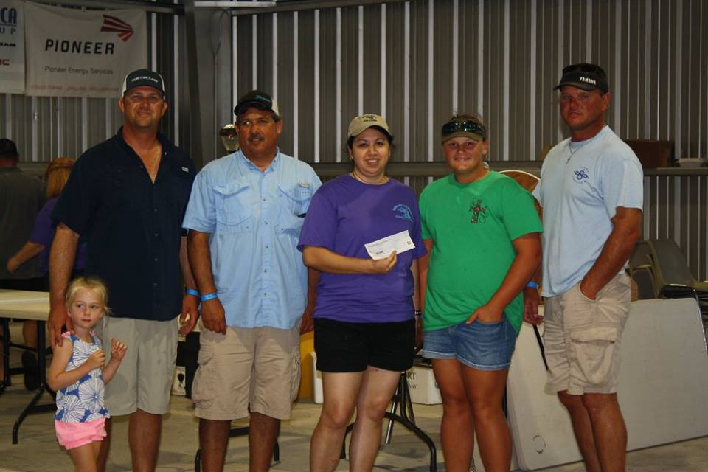
Calcutta Biggest Redfish-Sonny Leal

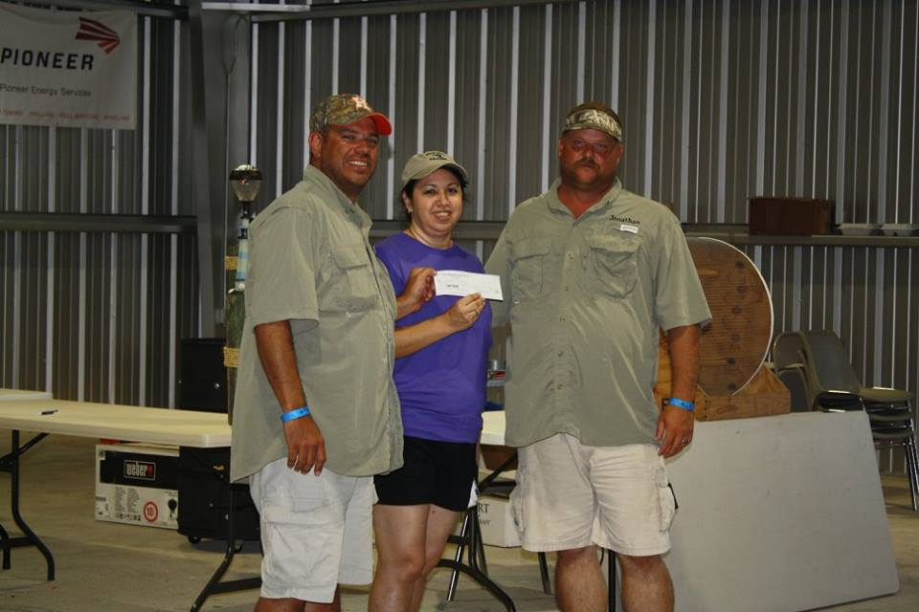
Calcutta 2nd Biggest Redfish-Walter Williams

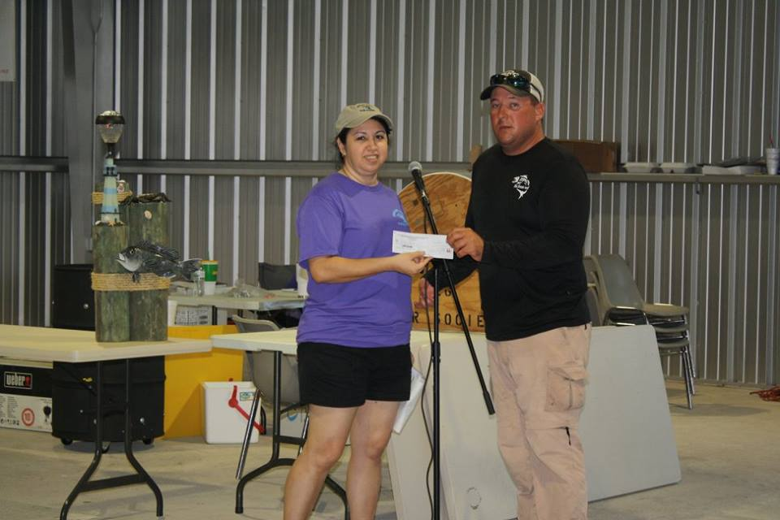
Calcutta Biggest Trout-Colby Becker

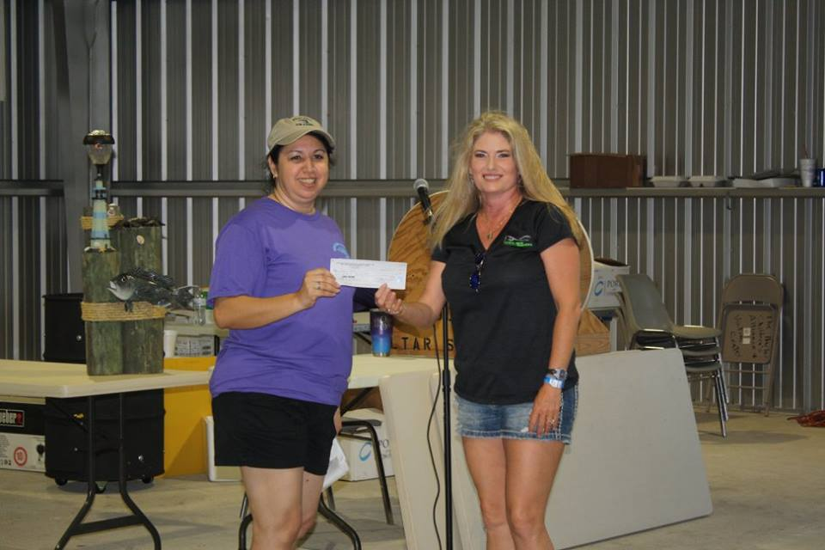
Calcutta 2nd Biggest Trout-Tracy Reed

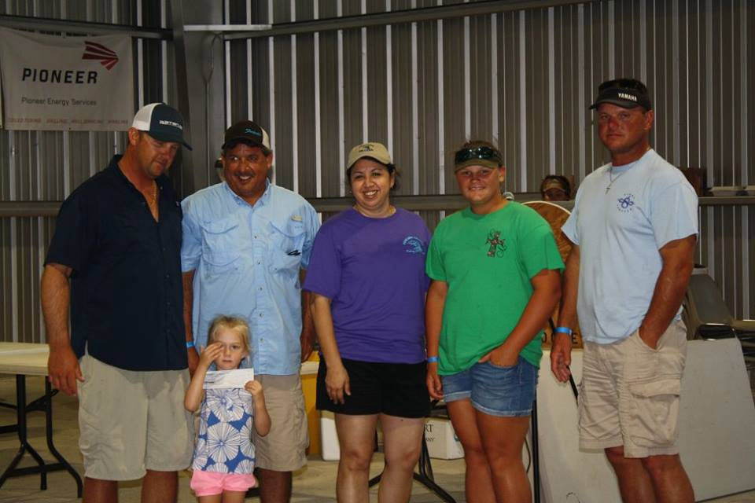
Calcutta Biggest Stringer Combo-Sonny Leal

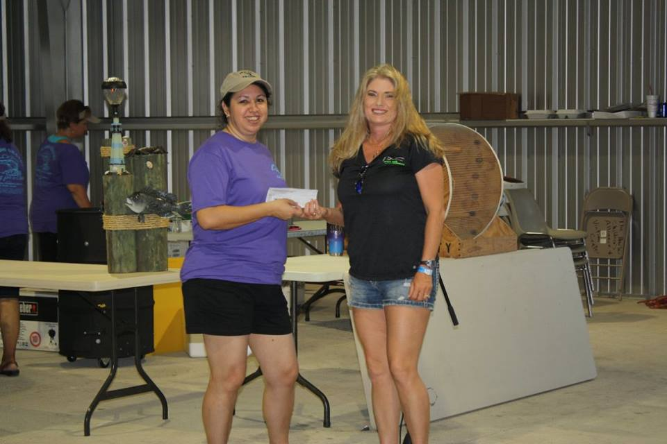
Calcutta 2nd Biggest Combo-Tracy Reed

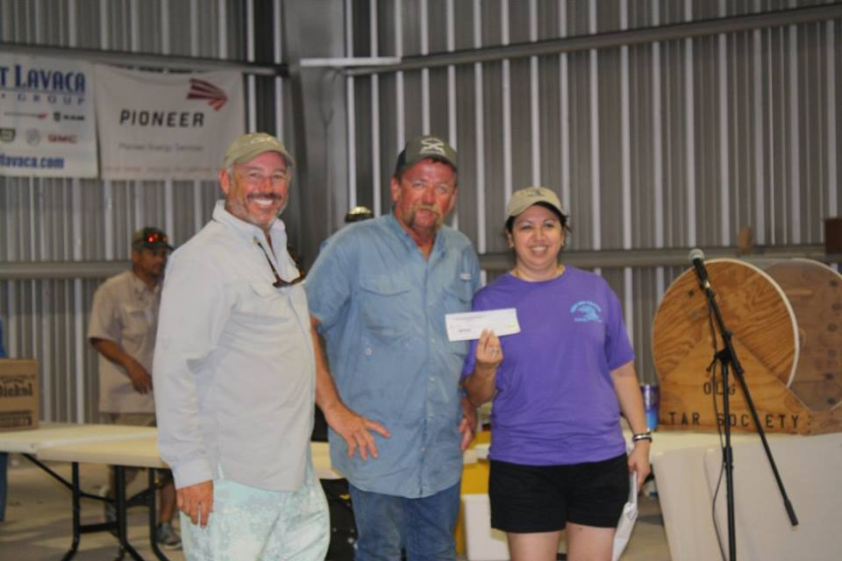
Calcutta Biggest King Fish-Sean Casey

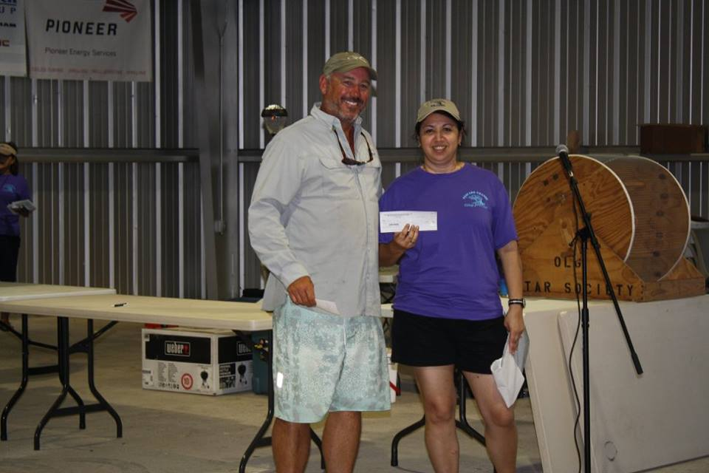
Calcutta Biggest Fish-Sean Casey

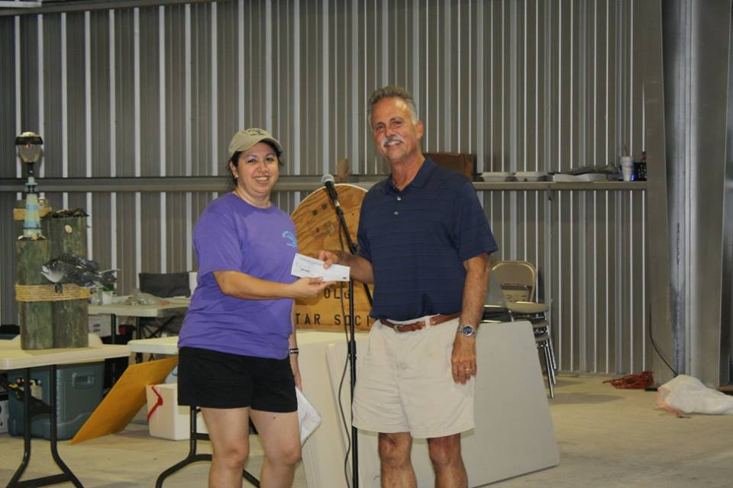
Calcutta Biggest Snapper-George Ganem
Calcutta 2nd Biggest Fish-George Ganem

